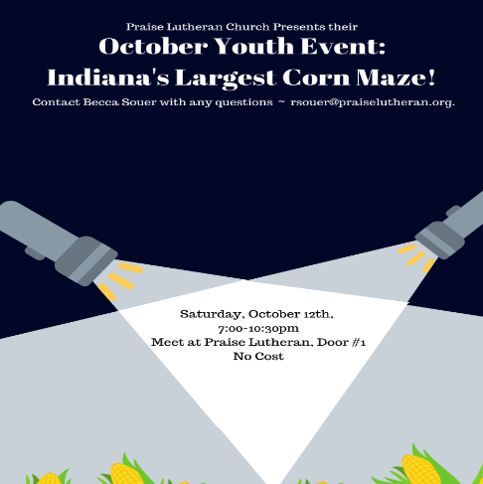
October Youth Event:
Indiana's Largest Corn Maze!
Praise Lutheran Church Presents their
Saturday, October 12th,
7:00-10:30pm
No Cost
Contact Becca Souer with any questions ~ rsouer@praiselutheran.org.

