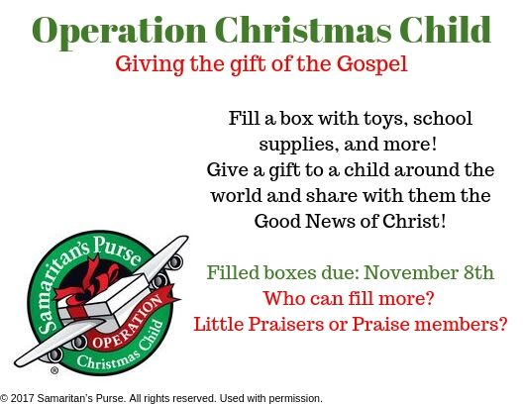
Operation Christmas Child
Calling all members of Praise Lutheran! This October we are packing shoe boxes to send around the world as Christmas gifts to children who may never have heard about our Savior. In these boxes we get to share the joy of a Christmas gift, while sharing the greatest gift of Christmas: God's Gospel. Please pick up a box TODAY and fill it with toys, school supplies, and select hygiene products (full list of acceptable items included in the box), not forgetting the $9 shipping cost. Return your filled (but unsealed) boxes to Praise no later than November 8th. Note: we are holding a friendly competition with our Little Praisers Preschool to see who can fill the greatest number of boxes. Good luck and thank you!

